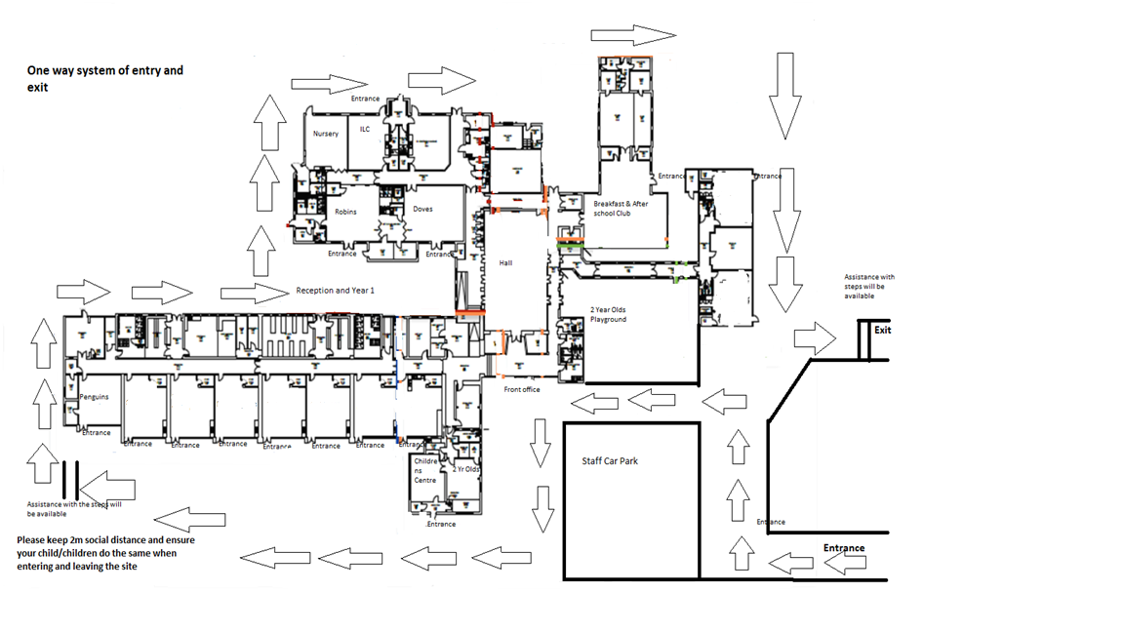

Hawks

Eagles

Kestrels

Falcons

Swifts

Ravens

Nightingales

Blackgates Primary Map of Classrooms Sept 2021